**REPORT**

**SHOP SALES DATA**

Introduction:

This dataset encapsulates a wealth of information regarding sales transactions, providing valuable insights into the dynamics of retail operations. With columns meticulously crafted to capture key facets of each transaction, including Date, Salesman, Item Name, Company, Quantity, and Amount, analysts and businesses alike gain access to a treasure trove of actionable data.

Whether it's uncovering trends, optimizing inventory management, or refining sales strategies, this dataset serves as an invaluable resource for driving informed decision-making and unlocking new avenues for growth.

Questionnaire:

1. Compare all the salesmen on the basis of profit earn.

2. Find out most sold product over the period of May-September.

3. Find out which of the two product sold the most over the year Computer or Laptop?

4. Which item yield most average profit?

5. Find out average sales of all the products and compare them.

Analytic:

1. Compare all the salesmen on the basis of profit earn.

Ans:- The comparison of all the salesmen on the basis of profit earned is given below:

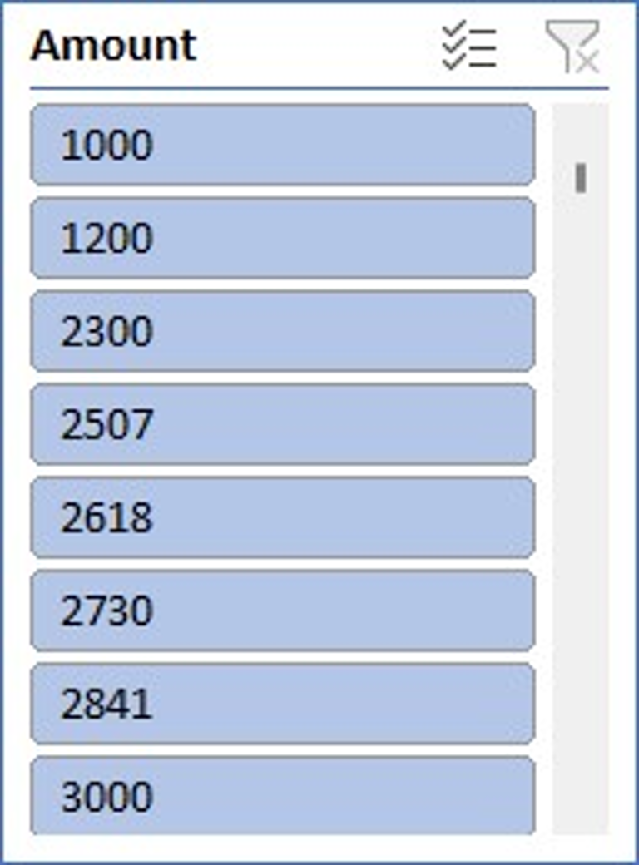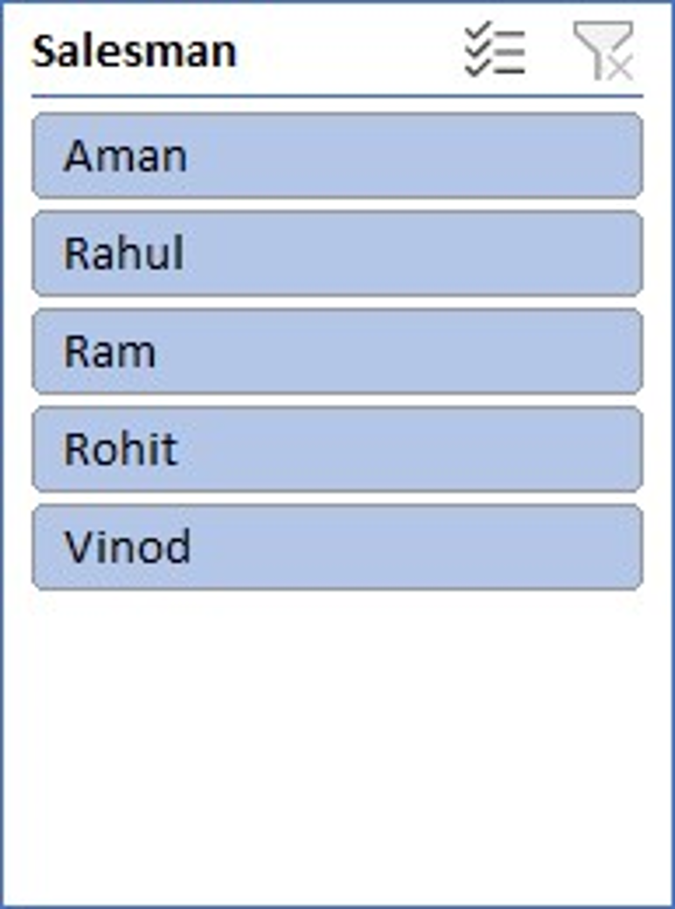

2. Find out most sold product over the period of May-September.

Ans:- To identify the most sold product over the period of May-September, we would need to analyze the sales data within this timeframe. By aggregating the quantity sold for each product across all transactions during this period and then determining which product has the highest total quantity sold, we can pinpoint the most popular item.

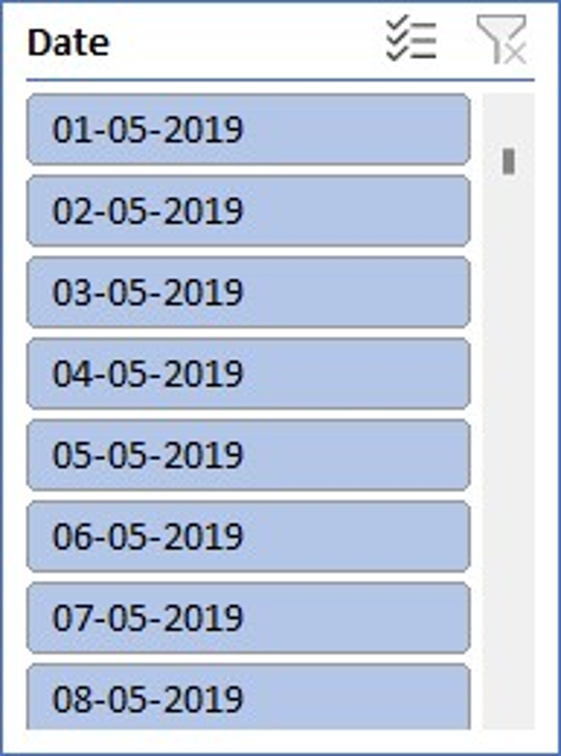 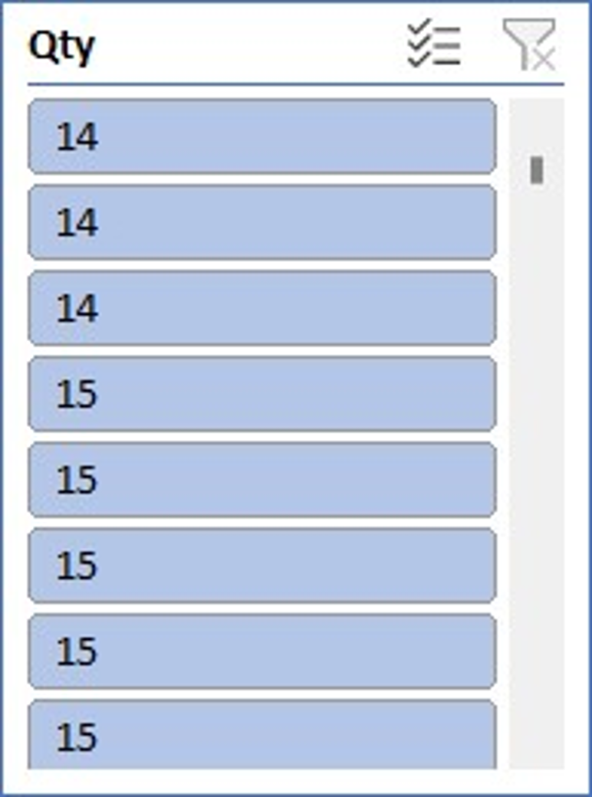 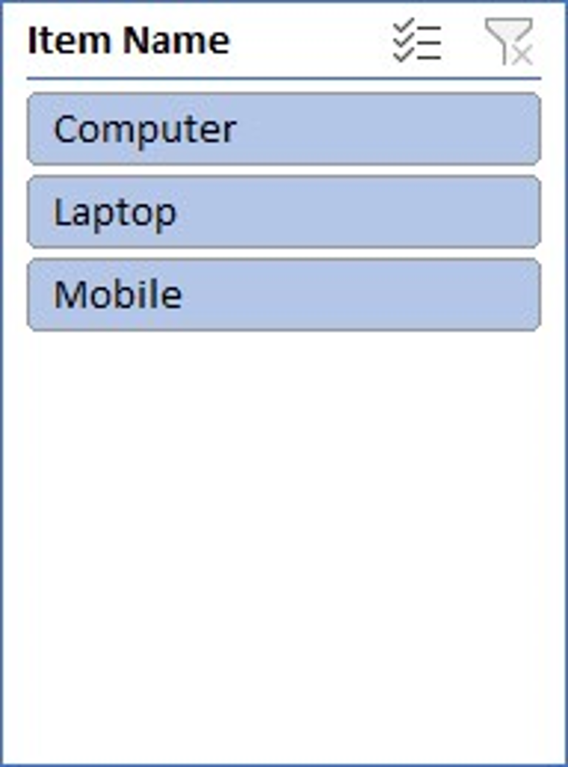

3. Find out which of the two product sold the most over the year Computer or Laptop?

Ans:- The two product sold the most over the year between computer or laptop :

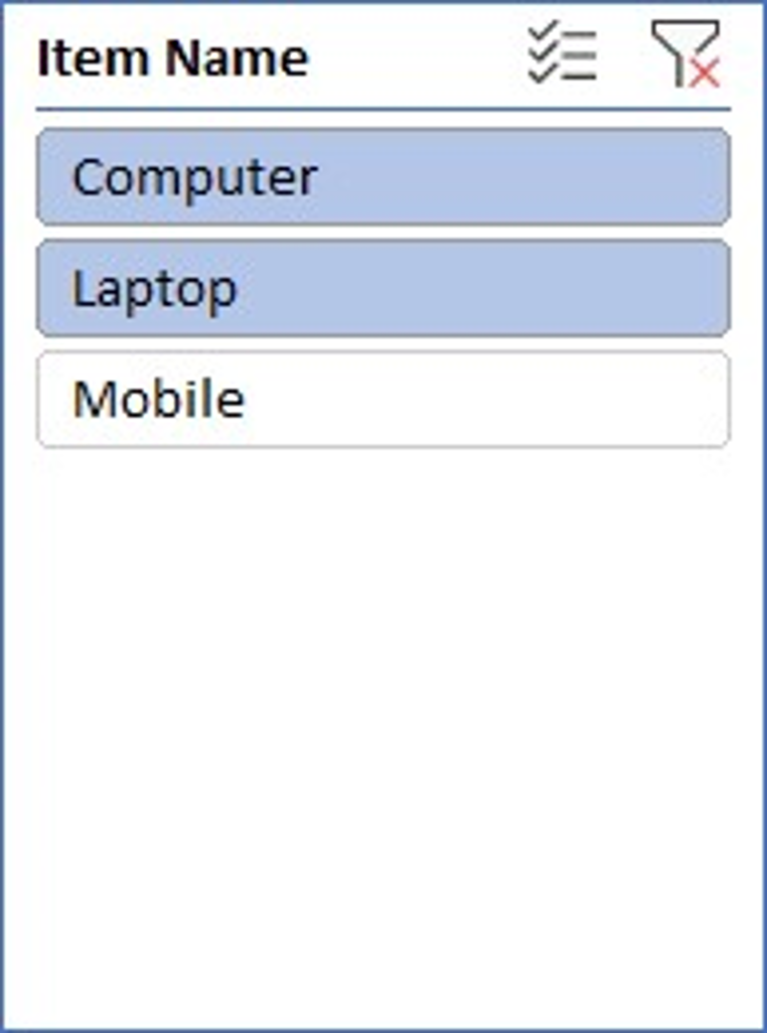 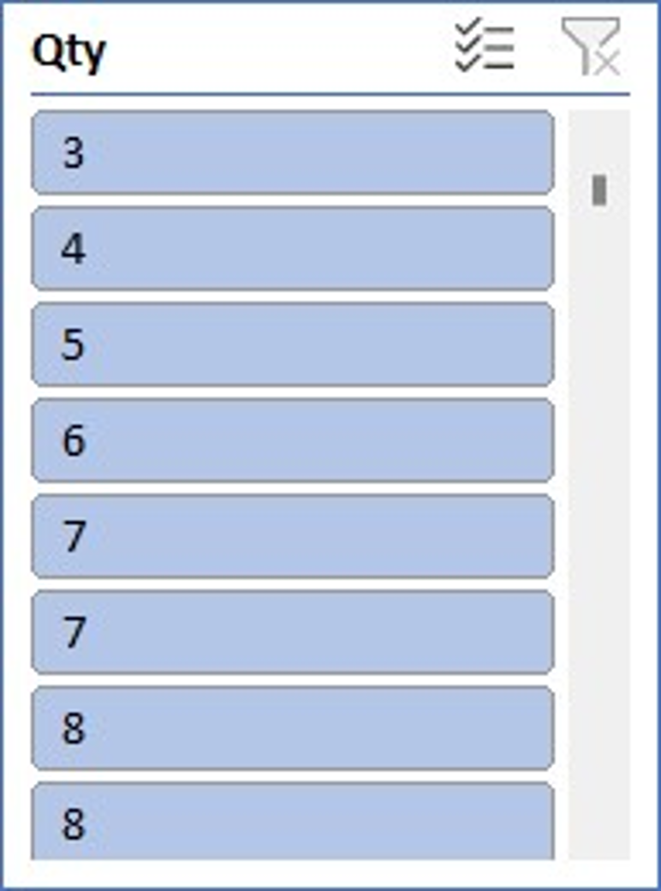

4 . Which item yield most average profit?

Ans:- The item that yields the most profit between laptop, computer and mobile is :

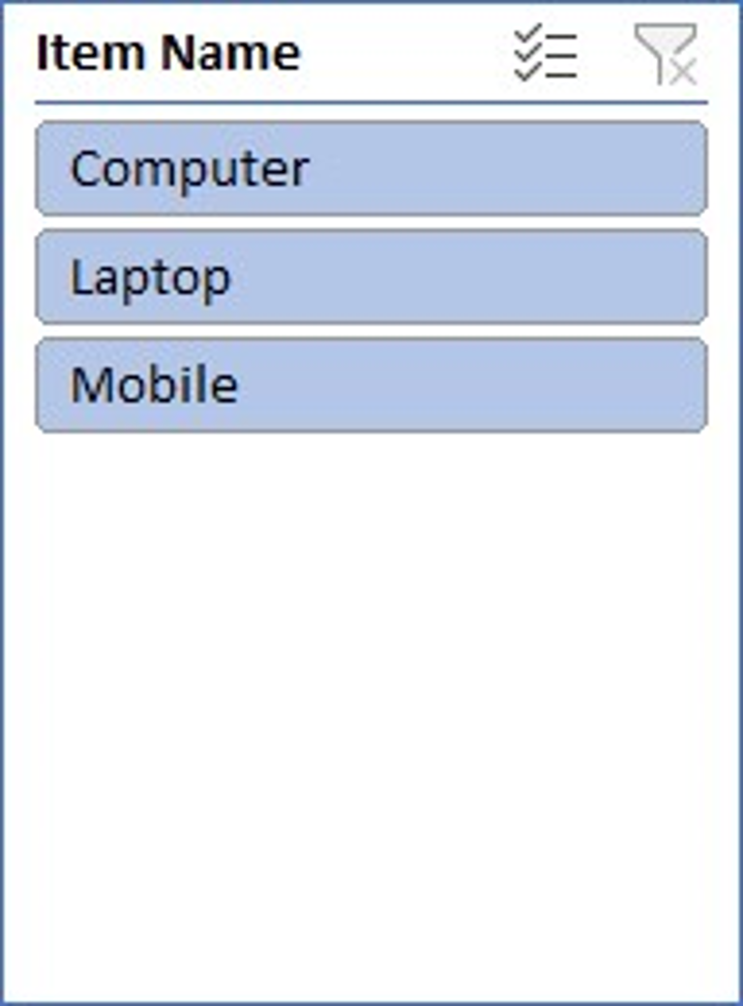 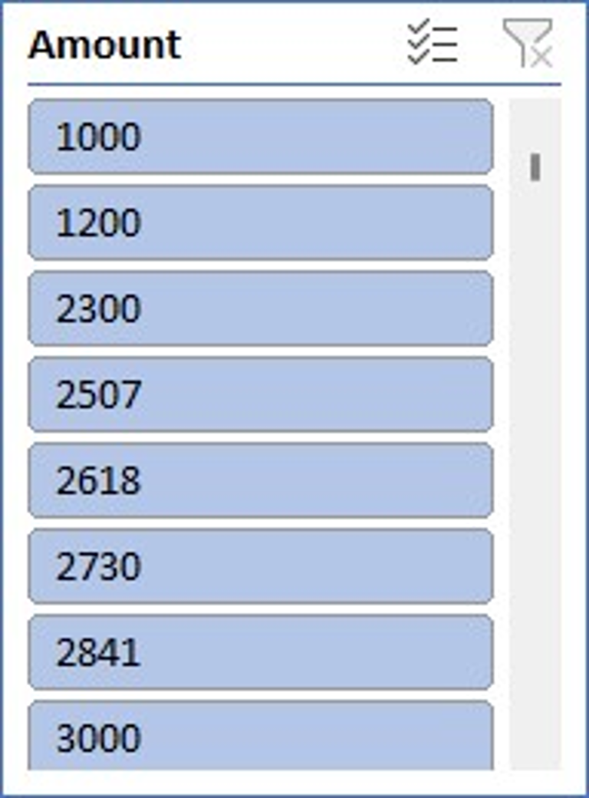

5. Find out average sales of all the products and compare them.

Ans:- The average sales of all the products with their respective comparison is :

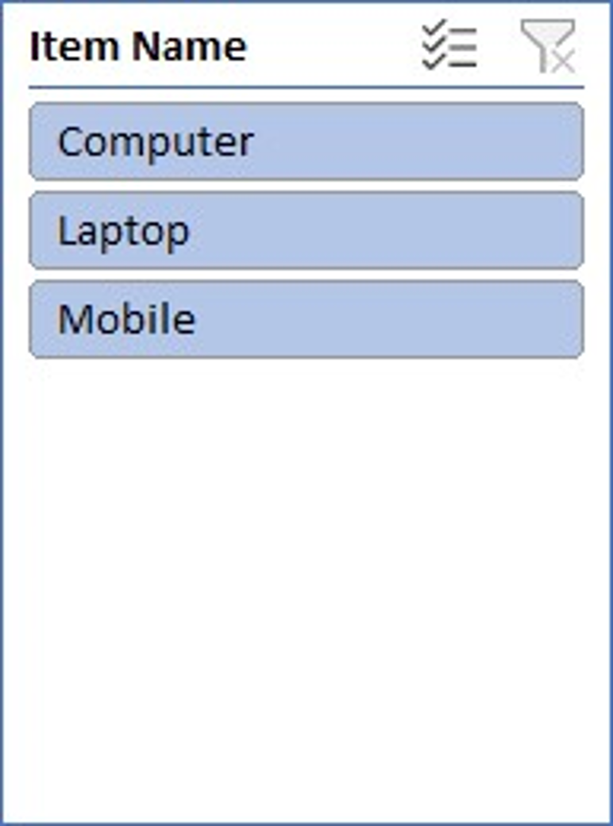

Conclusion and Review :

The shop sales dataset offers insights into sales trends, salesman performance, item popularity, and company performance. Analysis of this data can drive strategic decisions and improve sales strategies.

The dataset is well-structured and provides comprehensive information on sales transactions. It allows for various analyses, but could benefit from additional variables for deeper insights. Overall, it's a valuable resource for understanding sales dynamics and informing business decisions.

Regression: The regression model, with a significant p-value indicates a strong positive relationship between Amount and the profit earned and the outcome variable. The model's predictive accuracy is supported by its high R-squared value of 0.660.

|  |  |  |  |  |  |  |  |  |  |  |  |  |  |  |  |
| --- | --- | --- | --- | --- | --- | --- | --- | --- | --- | --- | --- | --- | --- | --- | --- |
| SUMMARY OUTPUT | | |  | |  | |  | |  | |  |  | |  | |
|  |  | |  | |  | |  | |  | |  |  | |  | |
|  |  | |  | |  | |  | |  | |  |  | |  | |
| *Regression Statistics* | | | |  | |  | |  | |  | | |  | |
| Multiple R | | 0.812617 | |  | |  | |  | |  | | |  | |
| R Square | | 0.660347 | |  | |  | |  | |  | | |  | |
| Adjusted R Square | | 0.629469 | |  | |  | |  | |  | | |  | |
| Standard Error | | 1215.119 | |  | |  | |  | |  | | |  | |
| Observations | | 13 | |  | |  | |  | |  | | |  | |
|  | |  | |  | |  | |  | |  | | |  | |
| ANOVA | |  | |  | |  | |  | |  | | |  | |
|  | | *df* | | *SS* | | *MS* | | *F* | | *Significance F* | | |  | |
| Regression | | 1 | | 31576697 | | 31576697 | | 21.38598 | | 0.000753 | | |  | |
| Residual | | 11 | | 16241653 | | 14776514 | |  | |  | | |  | |
| Total | | 12 | | 47818350 | |  | |  | |  | | |  | |
|  | |  | |  | |  | |  | |  | | |  | |
|  | | *Coefficients* | | *Standard Error* | | *t Stat* | | *P-value* | | *Lower 95%* | | | *Upper 95%* | |
| Intercept | | 244.7062 | | 754.0557 | | 0.32452 | | 0.751632 | | -1414.96 | | | 1904.372 | |
| X Variable | | 0.190729 | | 0.041243 | | 4.624498 | | 0.000735 | | 0.099954 | | | 0.281505 | |

Co-relation:

The correlation coefficient between units sold and revenue is 0.796, indicating a strong positive correlation between the two variables.

|  |  |  |
| --- | --- | --- |
|  | *Qty* | *Amount* |
| Column 1 | 1 |  |
| Column 2 | #DIV/0! | 1 |

Anova (Single Factor) :

The ANOVA results indicate a significant difference between the two groups , with 1 degree of freedom.

|  |  |  |  |  |  |  |
| --- | --- | --- | --- | --- | --- | --- |
| SUMMARY |  |  |  |  |  |  |
| Groups | Count | Sum | Average | Variance |  |  |
| Column 1 | 15 | 78.56643 | 5.237762 | 2.766871 |  |  |
| Column 2 | 15 | 50419.05 | 3361.27 | 3416099 |  |  |
|  |  |  |  |  |  |  |
| ANNOVA |  |  |  |  |  |  |
| Source of Variance | SS | df | MS | F | P-Value | F crit |
| Between Group | 84472135 | 1 | 84472135 | 49.45528 | 1.2E-07 | 4.195972 |
| Without Group | 47825420 | 28 | 170851 |  |  |  |
|  |  |  |  |  |  |  |
| Total | 1.32E+08 | 29 |  |  |  |  |

|  |  |  |
| --- | --- | --- |
|  |  |  |
|  |  |  |
|  |  |  |

Anova two factor with Replication:

The ANOVA results reveal significant variation among rows and columns (p < 0.001), with degrees of freedom (df) values of 10 respectively. The error term has a degree of freedom of 0

|  |  |  |  |  |  |  |
| --- | --- | --- | --- | --- | --- | --- |
| ANOVA |  |  |  |  |  |  |
| *Source of Variation* | *SS* | *df* | *MS* | *F* | *P-value* | *F crit* |
| Rows | 841600745 | 10 | 4160074 | 65535 | #NUM! | #NUM! |
| Columns | 0 | 0 | 65535 | 65535 | #NUM! | #NUM! |
| Error | 0 | 0 | 65535 |  |  |  |
|  |  |  |  |  |  |  |
| Total | 41600745 | 10 |  |  |  |  |

Anova two factor without Replication:

|  |  |  |  |  |  |  |
| --- | --- | --- | --- | --- | --- | --- |
| Summary | Count | Sum | Average | Variance |  |  |
| 4 | *1* | *7800* | *7800* | *#DIV/0!* |  |  |
| 5 | *1* | *3000* | *3000* | *#DIV/0!* |  |  |
| 4 | 1 | 2300 | 2300 | *#DIV/0!* |  |  |
| 3 | 1 | 7000 | 7000 | *#DIV/0!* |  |  |
| 3 | 1 | 1200 | 1200 | *#DIV/0!* |  |  |
| 4 | 1 | 2506.667 | 2506.667 | *#DIV/0!* |  |  |
| 5 | 1 | 2618.095 | 2618.095 | *#DIV/0!* |  |  |
| 6 | 1 | 2729.524 | 2729.524 | *#DIV/0!* |  |  |
| 7 | 1 | 2840.952 | 2840.952 | *#DIV/0!* |  |  |
| 6 | 1 | 4500 | 4500 | *#DIV/0!* |  |  |
| 7 | 1 | 3063.81 | 3063.81 | *#DIV/0!* |  |  |
|  |  |  |  |  |  |  |
| 1000 |  | 39559.05 | 3596.277 | 4160074 |  |  |

Descriptive Statistics:

|  |  |
| --- | --- |
| *Column1* | |
|  |  |
| Mean | 1000 |
| Standard Error | 0 |
| Median | 1000 |
| Mode | #N/A |
| Standard Deviation | #DIV/0! |
| Sample Variance | #DIV/0! |
| Kurtosis | #DIV/0! |
| Skewness | #DIV/0! |
| Range | 0 |
| Minimum | 1000 |
| Maximum | 1000 |
| Sum | 1000 |
| Count | 1 |

|  |  |  |  |  |  |  |  |  |  |
| --- | --- | --- | --- | --- | --- | --- | --- | --- | --- |
|  |  |  |  |  |  |  |  |  |  |